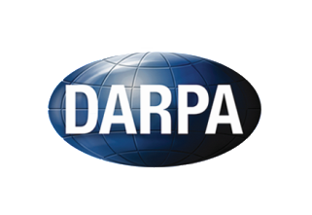 **Safer Warfighter Communications (SAFER)**

The SAFER program seeks to develop technology that will enable safe, resilient communications over the Internet, particularly in situations in which a third party is attempting to discover the identity or location of the end users, or block communications. The technology developed in the program will also provide the quality of service required to support applications such as electronic mail, instant messaging, voice over IP, and other media that promote effective communication.

**Program Manager**

Mr. Mike Walker

[Michael.Walker@darpa.mil](mailto:Michael.Walker@darpa.mil)

**\* Report a problem: john.cheng.ctr@darpa.mil**

**\* The content below has been generated by organizations which are partially funded by DARPA; the views and conclusions contained therein are those of the authors and should not be interpreted as necessarily representing the official policies or endorsements, either expressed or implied, of DARPA or the U.S. Government.**

**Software:**

**Publications:**